**CONCEPTUAL DESIGN DOCUMENT**

By

Natalie Gonzalez

Submitted to Dr. Isenberg and Dr. Adams  
of Embry-Riddle Aeronautical University  
in Partial Fulfillment of the Course Requirements for ME 407 and COM 420

9/29/23

# ABSTRACT

This conceptual design review presents an innovative stairlift system aimed at revolutionizing mobility solutions for individuals with and without limited mobility or disabilities. Traditional staircases have long presented challenges for all, necessitating the need for assistive devices. The proposed stair lift system offers a novel approach to address these challenges by providing a safe, efficient, and user-friendly solution for navigating stairs.

TABLE OF CONTENTS

ABSTRACT 1

1.0 PROBLEM STATEMENT 3

2.0 REQUIREMENTS 3

2.1 FUNCTION 3

2.2 INTERFACING 3

2.3 SAFETY 3

3.0 SYSTEM OVERVIEW 4

3.1 Previous Design 4

3.2 CONCEPT OF OPERATIONS 5

3.2.1 System Flowchart 5

3.2.2 System Overview 6

3.3 SYSTEM COMPONENTS 7

3.3.1 Sled 7

3.3.2 Joints 8

3.3.3 Rails 9

3.3.4 Electronics and Block Diagram 10

4.0 CONCLUSION 11

6.0 REFERENCES 11

# PROBLEM STATEMENT

Transporting heavy furniture up or down one flight of stairs is difficult and potentially dangerous.

2.0 REQUIREMENTS

## 2.1 FUNCTION

To achieve the goal set by the problem statement, the requirements of function are as follows:

2.1.1 - The system shall transport furniture repeatedly up or down one floor within a residential building.

2.1.2 - The system shall accommodate up to a 4-seater sofa.

2.1.3 - The system shall accommodate up to a 5-shelf bookshelf.

2.1.4 - The system shall be reusable.

## 2.2 INTERFACING

To ensure that the system is of a proper size that is capable of being transported and capable of fitting within the stairwells it operates in, the requirements of interface are as follows:

2.2.1 - The system shall fit within a standard stairway according to Section R311.7.1 of the 2021 International Residential Code (IRC)

2.2.2 - The system shall be transportable in the back of an average American pickup truck in addition to the transported furniture.

## 2.3 SAFETY

To ensure that the system is overall safe, and does not endanger the operator or environment, the requirements of safety are as follows:

2.3.1 - The system shall cause less injury and strain than an average moving job.

2.3.2 - The system shall not destructively alter the environment.

2.3.3 - The system shall not damage the furniture.

# 3.0 SYSTEM OVERVIEW

## 3.1 Previous Design

Figure 1: Previous Design [1]

This is a previous design that inspired the design of the system below. In this design a winch and pulley system are used to pull items upstairs, in order to bypass going up each step a rail system was created. The system also moves much like a conveyer belt. Issues I found with this design were that it is not practical for heavy furniture since the system has a flat base for the items to be placed on, even items with low weight could easily slide off. This could cause damage to the user and/or the item, failing to meet our requirements [2.3.1,2.3.3]. Another issue we found with this design is that it must be mounted to the stairs, which would not satisfy our requirements [2.3.2]. The last issue I found is that the rails must be set at a certain distance apart and that may not be within the minimum standards of stair widths which is mentioned above in the requirements [2.2.1].

Figure 2: Free Body Diagram of Existing Design [1]

## 3.2 CONCEPT OF OPERATIONS

The basic procedure to using this machine is to load a large piece of furniture onto the apparatus then set the system to transport the furniture up the stairs. This system should allow the user to select a direction then drive in that direction. The drive system for this design is a winch connected to a sled and a pulley creating a closed system to control the motion of the sled. The main safety feature of this system is a sensor that reads what is in front and behind the system, that is its stopping mechanism.

### 3.2.1 System Flowchart

Figure 3: Flowchart of System

Above is a high-level example of how the system will work with its inputs. Once the system is turned on the user must input the direction they would like to go, then the system will continually receive readings from the sensors. If and when the sensors read a distance value that is too small to be acceptable the system will implement a stop.

### 3.2.2 System Overview

Figure 4: Entire System Assembly

The entire system can cover up to 20 feet which is well within the standards specified in the requirements [2.2.1]. Note that the sled goes alongside the rail when the system is in use. Below in figure 5, the width of the entire system can be seen as about 2 feet in this design and configuration [2.1.3].

Figure 5: Top-side view of Assembled system

## 3.3 SYSTEM COMPONENTS

### 3.3.1 Sled

Figure 6: Sled

The sled for my design should have a long but thin base, between 5 and 6 feet in length and below 1.5 feet in width this ensures that the sled will fit in an average American pickup truck [2.2.2]. The dimensions mentioned above should be able to accommodate both a 4-seater sofa and a 5-shelf bookshelf [2.1.2, 2.1.3]. The cylinders will attach to the sled with a bracket (not pictured in figure 6), these cylinders will be free rotating. The brackets will include side braces that will have sections for straps to ensure that the furniture stays on the system. The cylinder must have a large diameter so that with a calculated offset the cylinders will have more than one rolling on steps at a time to go up the stairs smoothly. The last cylinder at the back of the stairs will be designed to have an offset so that when going down the stairs that cylinder will be in contact with the stairs until the system goes down one step. The large diameter and offset of the cylinders allow the system to go up and down a set of stairs repeatedly [2.1.1]. The lifted portion at the front of the sled should not allow for unexpected stopping or hitting of the stairs while going up [2.3.2]. The back of the sled also has an angled support so that furniture cannot slide down the stairs and potentially injure the user and the furniture [2.3.1,2.3.3]. The last component of the sled is the two attachments for the rope that will control the movement of the sled.

### 3.3.2 Joints

Figure 7 : Large Joint

The large joint, pictured above in figure 7, is used to connect the main rail and the rail with the winch on the end of it. These joints would be fitted with notches so that any angle can be set on with the joints. One each end of the joint is square block which are meant to be encased by the rail.

The small joint is very similar to the large joint, this join adheres to the main rail as well as the rail with a pulley on it. Incorporated into the design are holes to insert pins to keep the joint in place when the system is fully assembled.

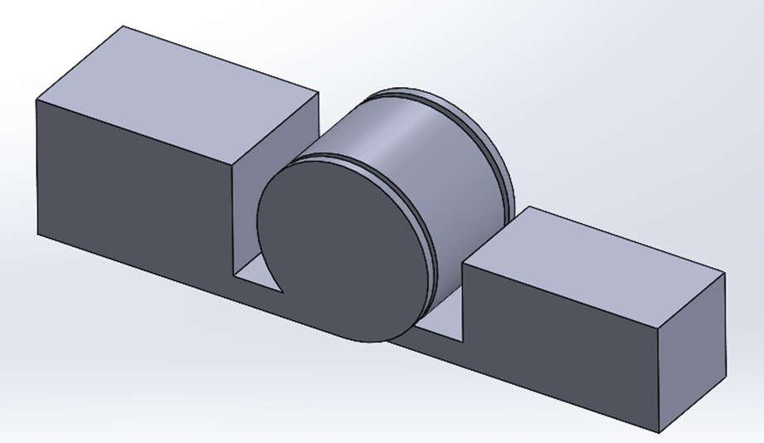

Figure 8: Small Joint

### 3.3.3 Rails

Figure 9: Stacked Rail Configuration

The rails are designed to hold both the winch and the pulley already fully integrated into the rails. The stacked configuration above, in figure 9, is short enough to fit on top of the sled when it is fully stacked [2.2.2]. In figure 10, the stacked configuration can fit on top of the sled which can make transportation more efficient.

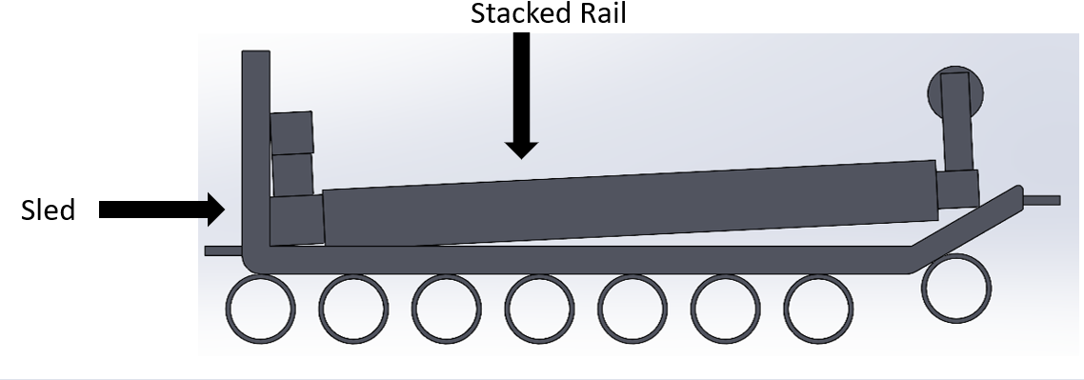

Figure 10: Transportation Configuration

### 3.3.4 Electronics and Block Diagram

This design includes a battery for a power source to be used to power the system, defining this battery as rechargeable allows for the system to be reusable [2.1.4]. Another mentionable component is the sensor in the block diagram below, using the most accurate and precise sensor we can find to ensure that the safety of the system is reliable.

Figure 11 : Component Block Diagram

# 4.0 CONCLUSION

I found that my design was heavily influenced by the patent mentioned above in section 3.1, but the flaws of that design according the system requirements were achieved through my design. There will be calculations needed to ensure that the true design of the system complies with natural forces. Additionally, the stopping mechanism may not be the safest, so that subsystem will need to be looked into further. In my design a mounting system for the rails was overlooked and I think that incorporating right triangles that can slide onto the bottom of the rails might be a great solution.

5.0 APPENDIX

|  |  |  |  |  |  |  |
| --- | --- | --- | --- | --- | --- | --- |
| **No.** | **Requirement** | **Verification Description** | **T** | **A** | **O** | **R** |
| 1 | 2.1.1 | Test load and trial | X |  |  |  |
| 2 | 2.1.2 | Measurement/Trial | X |  |  |  |
| 3 | 2.1.3 | Measurement/Trial | X |  |  |  |
| 4 | 2.1.4 | Repeated Trials | X |  | X |  |
| 5 | 2.2.1 | Measurement and Comparison | X |  |  | X |
| 6 | 2.2.2 | Measurement and Comparison | X |  |  | X |
| 7 | 2.3.1 | Trial, followed by Analysis and Comparison | X | X | X | X |
| 8 | 2.3.2 | Trial and Observation | X |  | X |  |
| 9 | 2.3.3 | Trial and Observation | X |  | X |  |

**T** – Test and Measurement; **A** – Analysis and Simulation;    
**O** – Observation and Inspection; **R** – Reference and Datasheet

(*Requirements verification matrix. | download table - researchgate*) [2]

# 6.0 REFERENCES

[1] M. B. ME, “Portable Stair Lift System,” PhD Thesis, WORCESTER POLYTECHNIC INSTITUTE, 2021.

[2] “Table 1. Requirements Verification Matrix.,” ResearchGate. Accessed: Sep. 29, 2023. [Online]. Available: https://www.researchgate.net/figure/Requirements-Verification-Matrix_tbl1_269163835